**INFORMATION MANAGEMENT**

**Exercise 9**

1. List the minimum perks package.

SELECT MIN(perks) FROM employee_data;

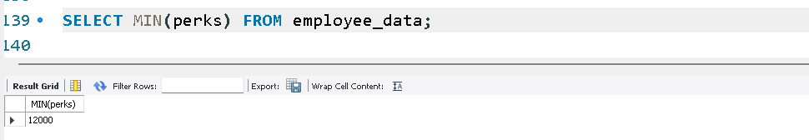

2. List the maximum salary given to a "Programmer".

SELECT MAX(salary) FROM employee_data WHERE title='Programmer';

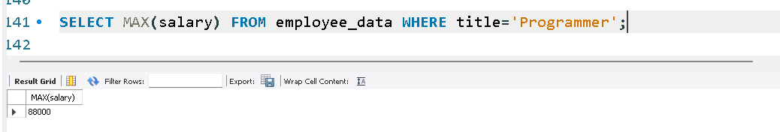

3. Display the age of the oldest “Marketing Executive”.

SELECT MAX(age) FROM employee_data WHERE title='Marketing Executive';

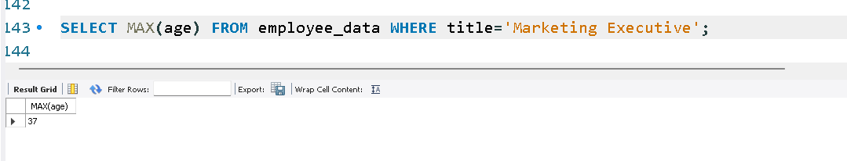

4. Find the first and last names of the oldest employee.

SELECT f_name, l_name FROM employee_data ORDER BY age DESC LIMIT 1;

